**ALI HASSAN 03-135211-005**

**ASSIGNMENT 2**

**TASK 1:**

#include <iostream>

using namespace std;

int main()

{

int vowels = 0;

int consonents = 0;

char arr[10] = { 'a', 'c', 'e', 'b', 'd', 'f', 'g', 'i', 'o', 'p' };

char* ptr = &arr[0];

for (int i = 0; i < 10; i++) {

*ptr = *(ptr + i);

if ((*ptr == 'a' || *ptr == 'e' || *ptr == 'i' || *ptr == 'o' || *ptr == 'u')) {

vowels++;

}

else

consonents++;

}

cout << "Entries: a,c,e,b,d,f,g,i,o,p" << endl;

cout << "\nTHIS IS THE NUMBER OF VOWELS: " << vowels << endl;

cout << "THIS IS THE NUMBER OF CONSONANTS: " << consonents << endl;

return 0;

}

**OUTPUT:**

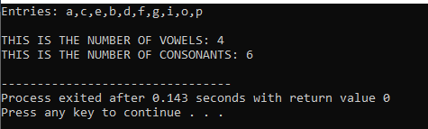

**Task 2:**

#include <iostream>

using namespace std;

int main()

{

char alphabet[27];

char* ptr;

ptr = alphabet;

for (int i = 0; i < 26; i++) {

*ptr = i + 'a';

cout << *ptr << endl;

}

return 0;

}

**Output:**

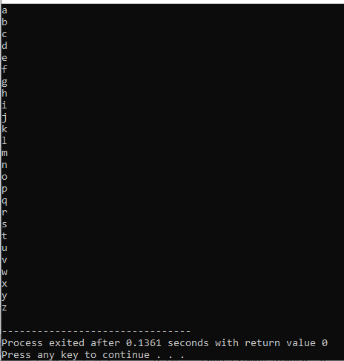

**Task 3:**

#include <iostream>

using namespace std;

int main()

{

char array[7];

cout << "Please enter your string: ";

cin >> array;

char* ptr;

cout << "Your entry: " << array << endl;

cout << "REVERSED: ";

for (int i = 7; i >= 0; i--) {

ptr = &array[i];

array[i] = *ptr;

cout << array[i];

}

return 0;

}

**Output:**

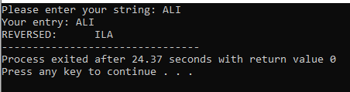

**Task 4:**

#include <iostream>

using namespace std;

class List {

private:

int arr[50];

int index;

public:

List();

void add(int a);

void remove(int a);

void removeAt(int key);

void addAt(int a, int index);

void search(int a);

void addAtStart(int a);

void addAtLast(int a);

void display();

};

List::List() {

//constructor

index = 0;

for (int i = 0; i < 50; i++) {

arr[i] = 0;

}

}

void List::add(int a) {

int* ptr;

ptr = &a;

int* ptr_arr = &arr[0];

for (int i = 0; i < 50; i++) {

if (*(ptr_arr + i) == 0) {

*(ptr_arr + i) = *ptr;

cout << "number added!" << endl;

break;

}

else

cout << "eror" << endl; break;

}

display();

}

void List::remove(int a) {

int* ptr;

ptr = &a;

int* ptr_arr = &arr[0];

for (int i = 0; i < 50; i++) {

if (*(ptr_arr + i) == *ptr) {

*(ptr_arr + i) = 0;

*(ptr_arr + i) = *(ptr_arr + i + 1);

cout << "Number: " << *ptr << " removed at index[" << *(ptr_arr + i) << "]" << endl;

}

}

display();

}

void List::removeAt(int key) {

int* ptr;

ptr = &key;

int* ptr_arr = &arr[0];

int num = *(ptr_arr + *ptr);

for (int i = *ptr; i < 50; i++) {

*(ptr_arr + i) = *(ptr_arr + i + 1);

}

cout << "Record: " << num << " at index [" << *ptr << "] removed!" << endl;

display();

}

void List::addAt(int a, int key) {

int* ptr, * ptr_key;

ptr = &a;

ptr_key = &key;

int* ptr_arr = &arr[0];

if (*(ptr_arr + *ptr_key) == 0) {

*(ptr_arr + *ptr_key) = *ptr;

cout << "Number added at index [" << *ptr_key << "]" << endl;

}

else {

for (int i = *ptr_key; i < 50; i++) {

*(ptr_arr + i + 1) = *(ptr_arr + i);

}

*(ptr_arr + *ptr_key) = *ptr;

cout << "Number added at index [" << *ptr_key << "]" << endl;

}

display();

}

void List::search(int a) {

int* ptr = &a;

int* ptr_arr = &arr[0];

for (int i = 0; i < 50; i++) {

if (*(ptr_arr + i) == *ptr) {

cout << "Record: " << *ptr << " found at index [" << *(ptr_arr + i) << "]" << endl;

}

}

}

void List::addAtStart(int a) {

int* ptr = &a;

int* ptr_arr = &arr[0];

if (*(ptr_arr + 0) == 0) {

*(ptr_arr + 0) = *ptr;

cout << "Number: " << *ptr << " added at the start of array index [0]" << endl;

}

else {

for (int i = 49; i >= 0; i--) {

*(ptr_arr + i) = *(ptr_arr + i - 1);

}

*(ptr_arr + 0) = *ptr;

cout << "Number: " << *ptr << " added at the start of array index [0]" << endl;

}

display();

}

void List::addAtLast(int a) {

int* ptr = &a;

int* ptr_arr = &arr[0];

if (*(ptr_arr + 49) == 0) {

*(ptr_arr + 49) = *ptr;

cout << "Number : " << *ptr << " added at last of array index[49]" << endl;

}

else {

for (int i = 0; i < 50; i++) {

*(ptr + i) = *(ptr_arr + i + 1);

}

cout << "Number : " << *ptr << " added at last of array index[49]" << endl;

}

display();

}

void List::display() {

for (int i = 0; i < 50; i++) {

// only printing non ZEro values!

if (arr[i] != 0)

cout << "index [" << arr[i] << "]" << endl;

}

}

int main() {

List list;

list.add(12);

list.search(12);

list.remove(12);

list.addAt(5, 5);

list.removeAt(5);

list.addAtStart(69);

list.addAtLast(68);

return 0;

}

**Output:**

